

Faculty of Technology and Engineering
Chandubhai S. Patel Institute of Technology (CSPIT) Department of Computer Science & Engineering
Date:15/08/2026
Laboratory Manual

Academic Year | : | 2026-27 | Semester | : | 3rd
Course code | : | ITUE203 | Course name | : | WEB DEVELOPMENT FRAMEWORKS

Practical – 2:-
Semantic HTML5 Pages with Accessibility-Ready Structure
Problem Statement:-
Develop static HTML5 skeletons for at least 10 StudentHub pages such as Home, About, Register, Login, Dashboard, Events, Profile, Contact, Admin, FAQ, and Feedback. Use semantic tags and accessibility-friendly
structure..
Objective:- To initiate the development of a semester-long StudentHub Portal by analyzing the problem requirements, identifying the target users and their roles, designing the key functional modules, creating a clear navigation flow, and planning a minimum 10-page website. The project also aims to establish a structured development workflow by preparing a sitemap, low-fidelity wireframes, project folder structure, README documentation, and a GitHub repository for version control and collaborative development.

https://github.com/D26CS122/StudentHub/tree/main/practical%202
Github Repository link:-
Screenshots:-
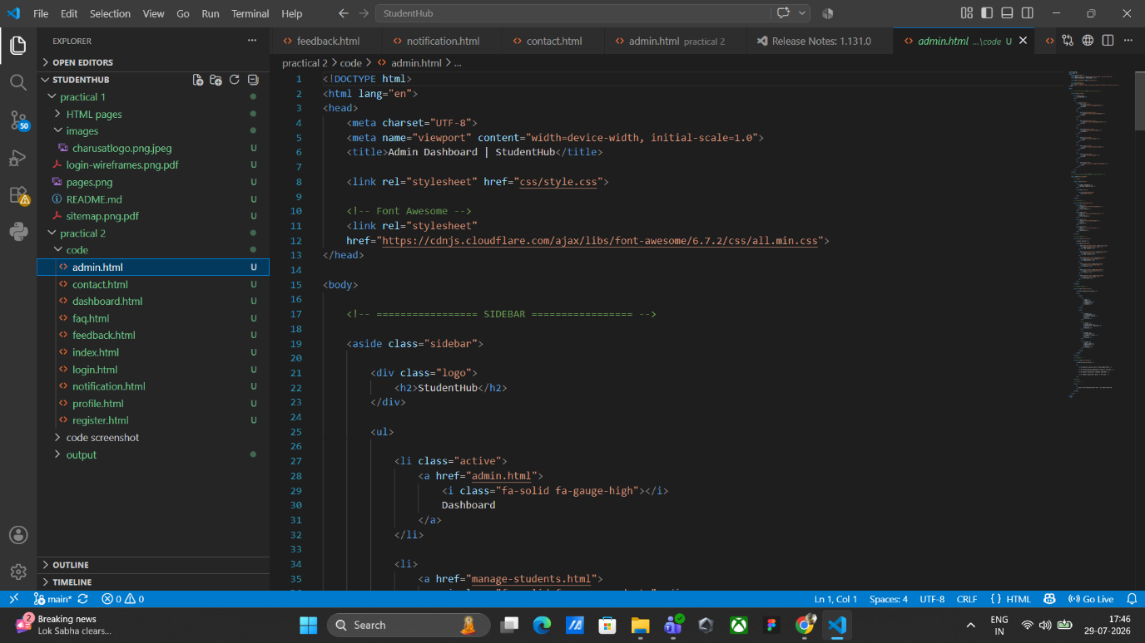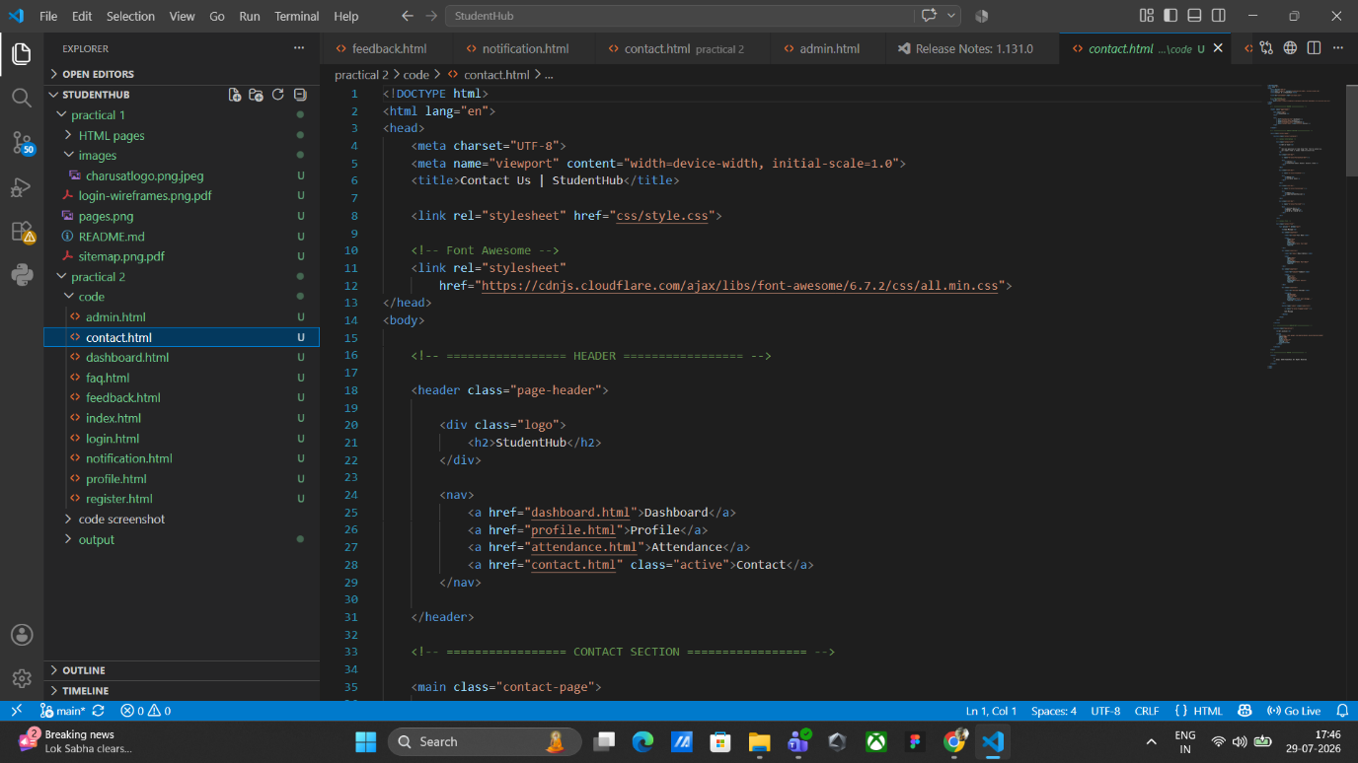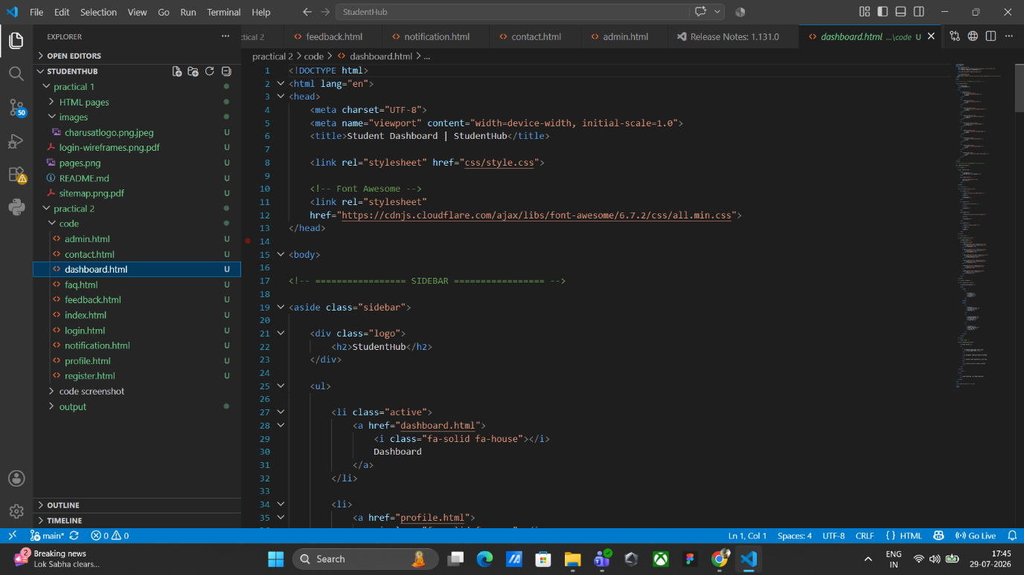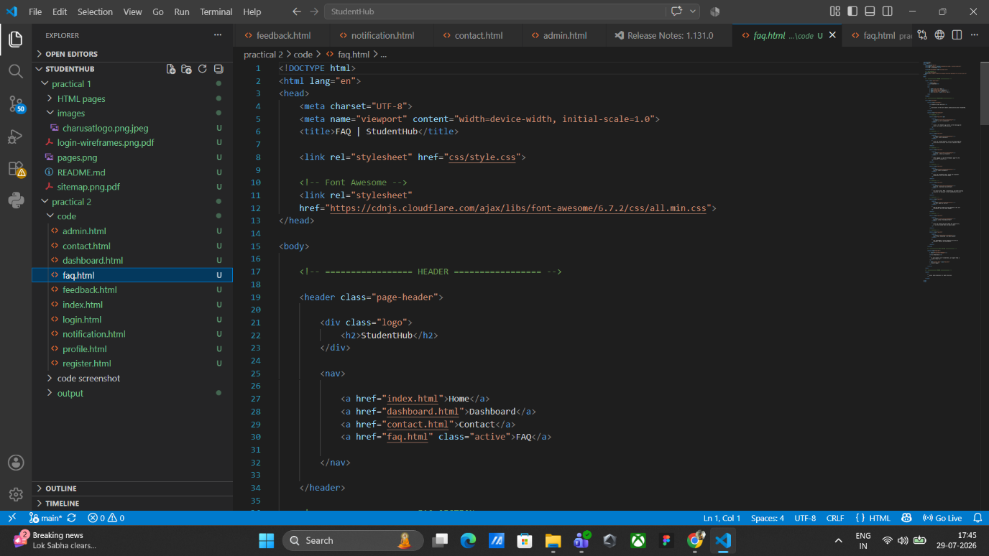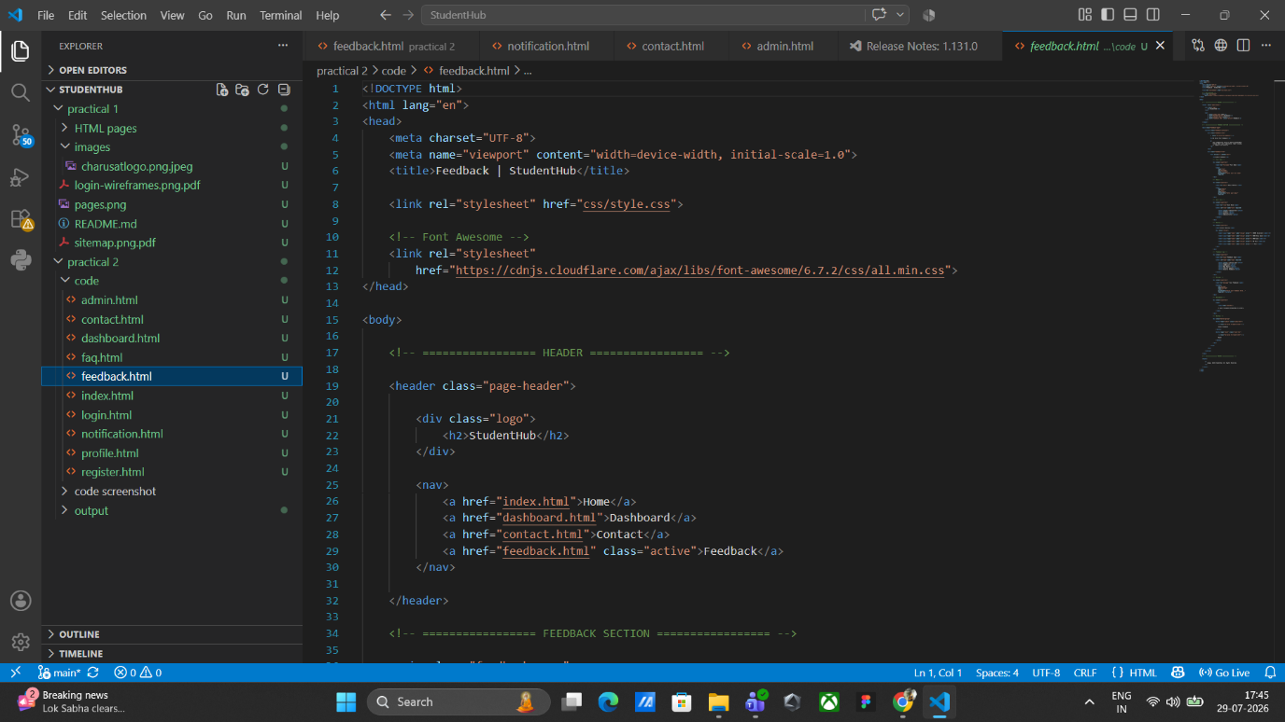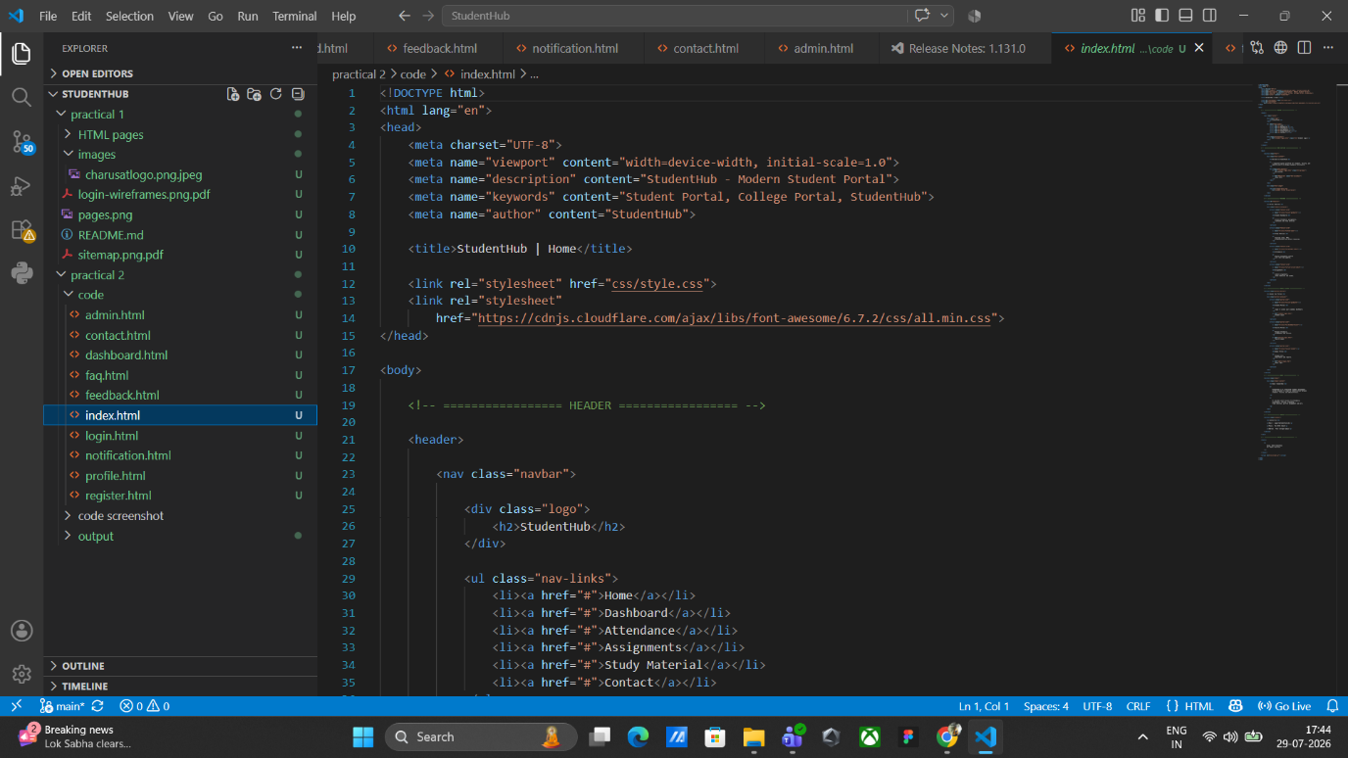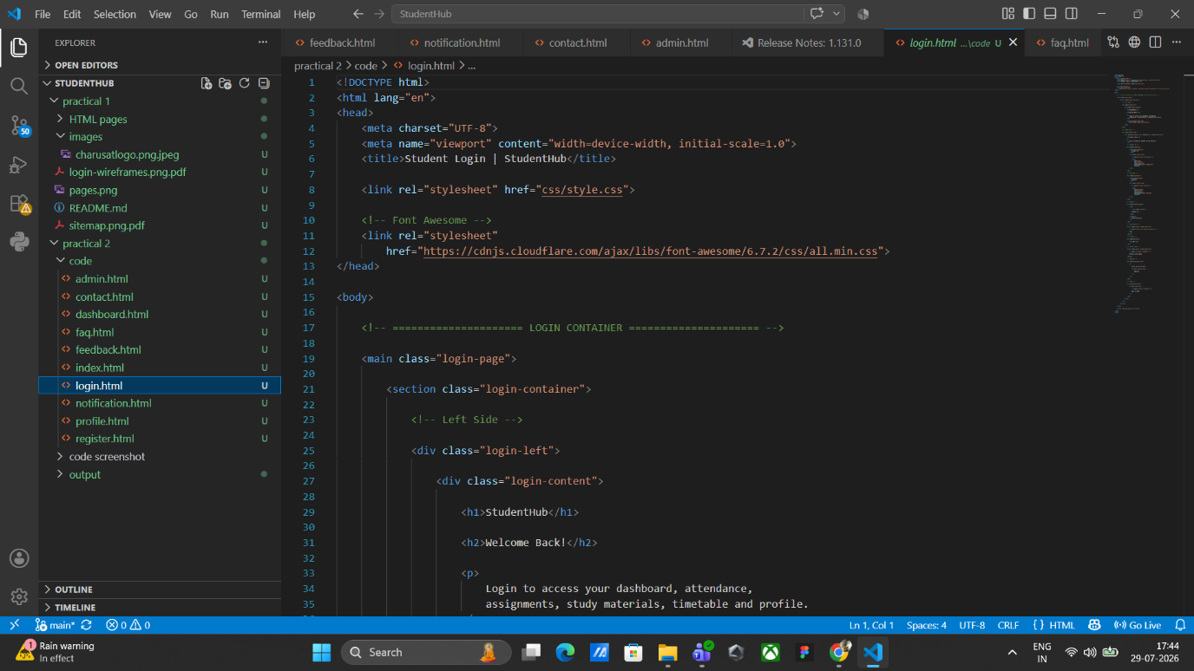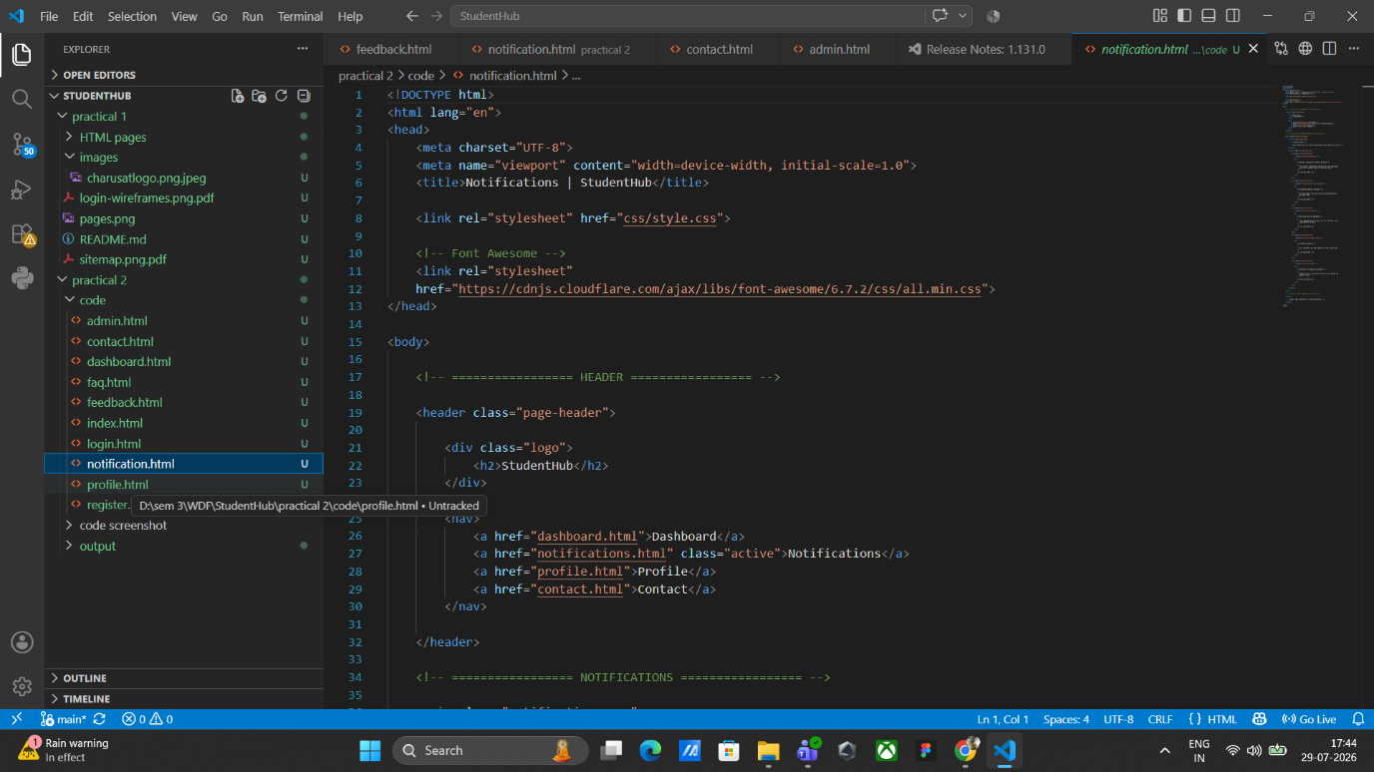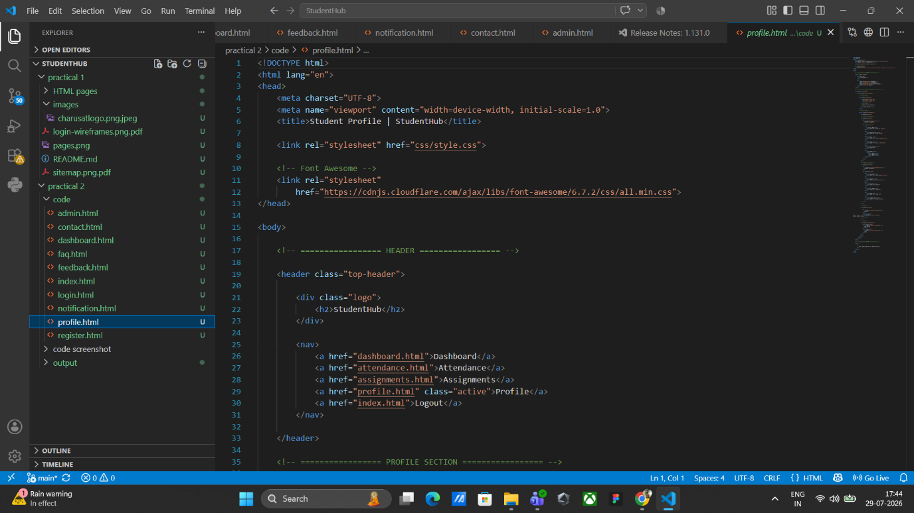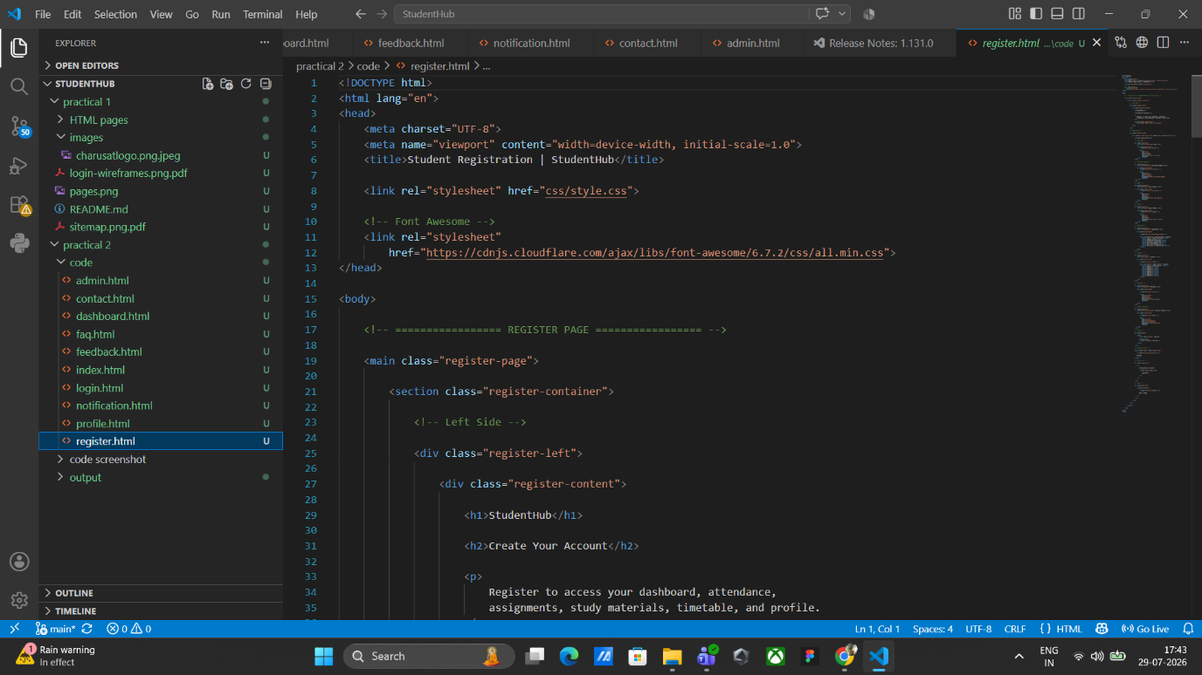

output :-

